**What is Software Engineering?**

The term **software engineering** is the product of two words, **software**, and **engineering**.

The **software** is a collection of integrated programs.

Software subsists of carefully-organized instructions and code written by developers on any of various particular computer languages.

Computer programs and related documentation such as requirements, design models and user manuals.

**Engineering** is the application of **scientific** and **practical** knowledge to **invent, design, build, maintain**, and **improve frameworks, processes, etc**.

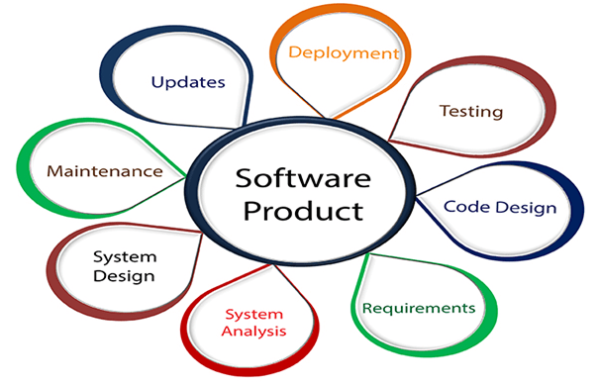

**Software Engineering** is an engineering branch related to the evolution of software product using well-defined scientific principles, techniques, and procedures. The result of software engineering is an effective and reliable software product.

The V-model is an SDLC model where execution of processes happens in a sequential manner in a V-shape. It is also known as **Verification and Validation model**.

The V-Model is an extension of the waterfall model and is based on the association of a testing phase for each corresponding development stage. This means that for every single phase in the development cycle, there is a directly associated testing phase. This is a highly-disciplined model and the next phase starts only after completion of the previous phase.

## V-Model - Design

Under the V-Model, the corresponding testing phase of the development phase is planned in parallel. So, there are Verification phases on one side of the ‘V’ and Validation phases on the other side. The Coding Phase joins the two sides of the V-Model.

The following illustration depicts the different phases in a V-Model of the SDLC.

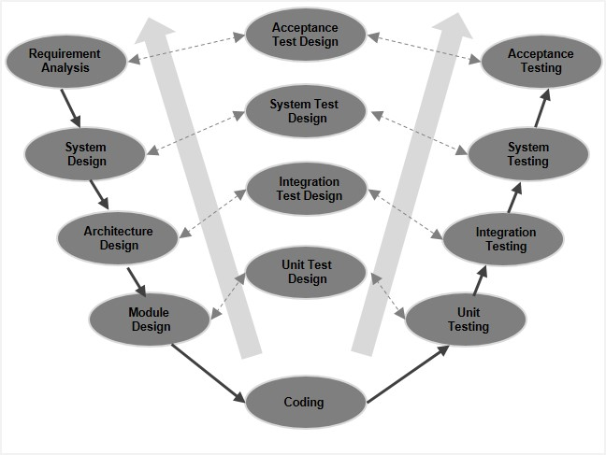

## V-Model - Verification Phases

There are several Verification phases in the V-Model, each of these are explained in detail below.

### Business Requirement Analysis

This is the first phase in the development cycle where the product requirements are understood from the customer’s perspective. This phase involves detailed communication with the customer to understand his expectations and exact requirement. This is a very important activity and needs to be managed well, as most of the customers are not sure about what exactly they need. The **acceptance test design planning** is done at this stage as business requirements can be used as an input for acceptance testing.

### System Design

Once you have the clear and detailed product requirements, it is time to design the complete system. The system design will have the understanding and detailing the complete hardware and communication setup for the product under development. The system test plan is developed based on the system design. Doing this at an earlier stage leaves more time for the actual test execution later.

### Architectural Design

Architectural specifications are understood and designed in this phase. Usually more than one technical approach is proposed and based on the technical and financial feasibility the final decision is taken. The system design is broken down further into modules taking up different functionality. This is also referred to as **High Level Design (HLD)**.

The data transfer and communication between the internal modules and with the outside world (other systems) is clearly understood and defined in this stage. With this information, integration tests can be designed and documented during this stage.

### Module Design

In this phase, the detailed internal design for all the system modules is specified, referred to as **Low Level Design (LLD)**. It is important that the design is compatible with the other modules in the system architecture and the other external systems. The unit tests are an essential part of any development process and helps eliminate the maximum faults and errors at a very early stage. These unit tests can be designed at this stage based on the internal module designs.

## Coding Phase

The actual coding of the system modules designed in the design phase is taken up in the Coding phase. The best suitable programming language is decided based on the system and architectural requirements.

The coding is performed based on the coding guidelines and standards. The code goes through numerous code reviews and is optimized for best performance before the final build is checked into the repository.

## Validation Phases

The different Validation Phases in a V-Model are explained in detail below.

### Unit Testing

Unit tests designed in the module design phase are executed on the code during this validation phase. Unit testing is the testing at code level and helps eliminate bugs at an early stage, though all defects cannot be uncovered by unit testing.

### Integration Testing

Integration testing is associated with the architectural design phase. Integration tests are performed to test the coexistence and communication of the internal modules within the system.

### System Testing

System testing is directly associated with the system design phase. System tests check the entire system functionality and the communication of the system under development with external systems. Most of the software and hardware compatibility issues can be uncovered during this system test execution.

### Acceptance Testing

Acceptance testing is associated with the business requirement analysis phase and involves testing the product in user environment. Acceptance tests uncover the compatibility issues with the other systems available in the user environment. It also discovers the non-functional issues such as load and performance defects in the actual user environment.

## V- Model ─ Application

V- Model application is almost the same as the waterfall model, as both the models are of sequential type. Requirements have to be very clear before the project starts, because it is usually expensive to go back and make changes. This model is used in the medical development field, as it is strictly a disciplined domain.

The following pointers are some of the most suitable scenarios to use the V-Model application.

* Requirements are well defined, clearly documented and fixed.
* Product definition is stable.
* Technology is not dynamic and is well understood by the project team.
* There are no ambiguous or undefined requirements.
* The project is short.

## V-Model - Pros and Cons

The advantage of the V-Model method is that it is very easy to understand and apply. The simplicity of this model also makes it easier to manage. The disadvantage is that the model is not flexible to changes and just in case there is a requirement change, which is very common in today’s dynamic world, it becomes very expensive to make the change.

The **advantages** of the V-Model method are as follows −

* This is a highly-disciplined model and Phases are completed one at a time.
* Works well for smaller projects where requirements are very well understood.
* Simple and easy to understand and use.
* Easy to manage due to the rigidity of the model. Each phase has specific deliverables and a review process.

The **disadvantages** of the V-Model method are as follows −

* High risk and uncertainty.
* Not a good model for complex and object-oriented projects.
* Poor model for long and ongoing projects.
* Not suitable for the projects where requirements are at a moderate to high risk of changing.
* Once an application is in the testing stage, it is difficult to go back and change a functionality.
* No working software is produced until late during the life cycle.



## The various phases of incremental model are as follows:

**1. Requirement analysis:** In the first phase of the incremental model, the product analysis expertise identifies the requirements. And the system functional requirements are understood by the requirement analysis team. To develop the software under the incremental model, this phase performs a crucial role.

**2. Design & Development:** In this phase of the Incremental model of SDLC, the design of the system functionality and the development method are finished with success. When software develops new practicality, the incremental model uses style and development phase.

**3. Testing:** In the incremental model, the testing phase checks the performance of each existing function as well as additional functionality. In the testing phase, the various methods are used to test the behavior of each task.

**4. Implementation:** Implementation phase enables the coding phase of the development system. It involves the final coding that design in the designing and development phase and tests the functionality in the testing phase. After completion of this phase, the number of the product working is enhanced and upgraded up to the final system product

**Advantage of Incremental Model**

* Errors are easy to be recognized.
* Easier to test and debug
* More flexible.
* Simple to manage risk because it handled during its iteration.
* The Client gets important functionality early.

**Disadvantage of Incremental Model**

* Need for good planning
* Total Cost is high.
* Well defined module interfaces are needed.

# **Prototype Model**

The prototype model requires that before carrying out the development of actual software, a working prototype of the system should be built. A prototype is a toy implementation of the system. A prototype usually turns out to be a very crude version of the actual system, possible exhibiting limited functional capabilities, low reliability, and inefficient performance as compared to actual software. In many instances, the client only has a general view of what is expected from the software product. In such a scenario where there is an absence of detailed information regarding the input to the system, the processing needs, and the output requirement, the prototyping model may be employed.

**Advantage of Prototype Model**

1. Reduce the risk of incorrect user requirement
2. Good where requirement are changing/uncommitted
3. Regular visible process aids management
4. Support early product marketing
5. Reduce Maintenance cost.
6. Errors can be detected much earlier as the system is made side by side.

**Disadvantage of Prototype Model**

1. An unstable/badly implemented prototype often becomes the final product.
2. Require extensive customer collaboration
   * Costs customer money
   * Needs committed customer
   * Difficult to finish if customer withdraw
   * May be too customer specific, no broad market
3. Difficult to know how long the project will last.
4. Easy to fall back into the code and fix without proper requirement analysis, design, customer evaluation, and feedback.
5. Prototyping tools are expensive.
6. Special tools & techniques are required to build a prototype.
7. It is a time-consuming process.

## What is UML

The UML stands for Unified modelling language, is a standardized general-purpose visual modelling language in the field of Software Engineering. It is used for specifying, visualizing, constructing, and documenting the primary artifacts of the software system. It helps in designing and characterizing, especially those software systems that incorporate the concept of Object orientation. It describes the working of both the software and hardware systems.

**Goals of UML**

* Since it is a general-purpose modelling language, it can be utilized by all the modelers.
* UML came into existence after the introduction of object-oriented concepts to systemize and consolidate the object-oriented development, due to the absence of standard methods at that time.
* The UML diagrams are made for business users, developers, ordinary people, or anyone who is looking forward to understand the system, such that the system can be software or non-software.
* Thus it can be concluded that the UML is a simple modelling approach that is used to model all the practical systems.

**Characteristics of UML**

The UML has the following features:

* It is a generalized modelling language.
* It is distinct from other programming languages like C++, Python, etc.
* It is interrelated to object-oriented analysis and design.
* It is used to visualize the workflow of the system.
* It is a pictorial language, used to generate powerful modeling artifacts.

**Conceptual Modelling**

Before moving ahead with the concept of UML, we should first understand the basics of the conceptual model.

A conceptual model is composed of several interrelated concepts. It makes it easy to understand the objects and how they interact with each other. This is the first step before drawing UML diagrams.

Following are some object-oriented concepts that are needed to begin with UML:

* **Object:** An object is a real-world entity. There are many objects present within a single system. It is a fundamental building block of UML.
* **Class:** A class is a software blueprint for objects, which means that it defines the variables and methods common to all the objects of a particular type.
* **Abstraction:** Abstraction is the process of portraying the essential characteristics of an object to the users while hiding the irrelevant information. Basically, it is used to envision the functioning of an object.
* **Inheritance:** Inheritance is the process of deriving a new class from the existing ones.
* **Polymorphism:** It is a mechanism of representing objects having multiple forms used for different purposes.
* **Encapsulation:** It binds the data and the object together as a single unit, enabling tight coupling between them.